SPARK: Simple Play Adaptations to Reference for Kids

First-Then Flip Schedule
Description: | Image:
This specific First-Then Flip Schedule consists of black velcro sensitive (loop) fabric pages for attaching word/picture prompts for task order measures 6” x 9” with a clear pocket for storing extra pictures on the back. It is designed for you to add your own words signifying the order of step One and Two, or activity and reinforcer, to help motivate students- then flip to the next task. | 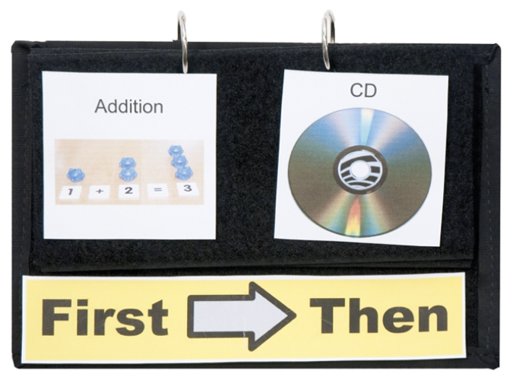  Purchasing Information

Who Might Benefit?
Those who…
• can successfully follow classroom routines when they have a visual “map” of the sequence of those activities.
• are not yet ready for a more complex visual schedule.
• need help completing a less desired task or activity.
• become anxious about or over fixated on classroom activities.
• do best with a structured and predictable environment.
• experience difficulty understanding verbal directions.
• are motivated by being able to see and physically manipulate a schedule to show completed work.

Why Use?
Provides an opportunity to…
• “see” what they are going to do “first” and “then” what they are going to do next through the use of objects, pictures, or words.
• be introduced to new tasks, activities, or events in a manner that the child understands and may be more motivated to complete.
• transition between activities with greater independence.
• follow a sequence and order for task completion.
• have an understanding of expectations.
Instructions for Use: | Adaptation Ideas:
Environmental Considerations  - Should accompany the child throughout the day in all environments.  - Supporting objects, visuals, or word cards should be available to staff in the environments in which they are needed so that the First Then schedule can be referenced and adjusted as activities are introduced and completed.  Positioning  - Should be displayed and referred where the child can see it during the activities in which it is being used.  Alternate Positioning  - Position so that it can be easily viewed and manipulated by the child.  Basic Play/Use  - Present the schedule to the child by naming and pointing to the sequence on the schedule.  - Be sure the “Then” activity is available for the child when the “First” activity is completed and follows immediately.  - Reference the “First” activity object, symbol, or word and indicate it has been completed, and the child can now engage in the “Then” activity.  - Use with an individual child or a whole group.  Extended Play/Use  - Allow the child to choose the “Then” activity when appropriate. | Optional Additional Materials/Supplies  - Velcro  - Foam Board  - Stabilizing sheet, carpet square  Build It Up  - Reinforce the pages with cardboard backing if it is hard for the child to flip the pages.  - Add page fluffers created from popsicle sticks, coffee stirrers, pom poms, etc. to separate the pages and make them easier to grasp and turn.  Stabilize It  - Fasten the schedule to a flat or vertical surface with Velcro so that the pages do not shift during viewing or manipulating.  Simplify It  - Use objects to show the sequence of activities  Contain It  - Place completed “Firsts” and “Thens” in provided plastic sleeve on the back of the First Then Flip Schedule or into an envelope so the child can see what they have accomplished.  Add Sensory Cues  - Use real objects, symbols that have been outlined with puffy paint, or high contrast symbols.  - Be sure and narrate or explain the function of the First Then Flip Schedule, emphasizing the words “first” and “then”.  Alternative Uses  - Paper-based First-Then schedules  - Add one or more activities to complete between the First and Then.  DIY Alternatives  - First-Then visuals are easy to make and can be done to match the individual’s communication mode by using photographs, picture icons, written words, objects, or even apps.  - Download pdf from OCALI Autism Center Grab and Go Resource Gallery of Interventions.  - Write down “First” and “Then” on paper or dry erase board.

Additional Considerations:
- Add one or more activities to complete between the First and Then (Ex. First-Next-Then).
- Could be used with a timer, however, some children may find timers distracting and anxiety producing. Please be sure to monitor the child’s responses when using the timers.

Ohio Early Learning Standards:
- AL: Engagement and Persistence: Completes activities with increasingly complex steps (1.b.).

Words to Encourage Play/Use
First  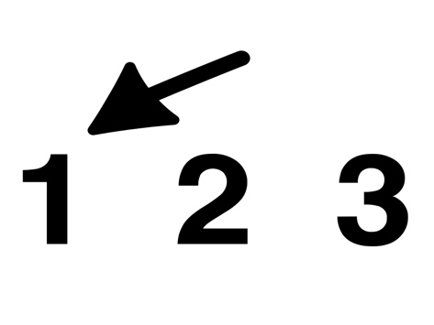 | Then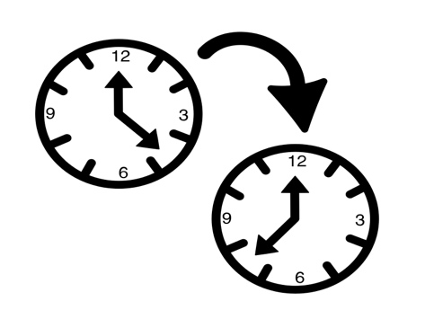 | Next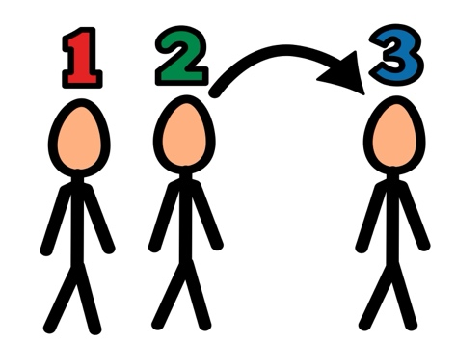
Done | Flip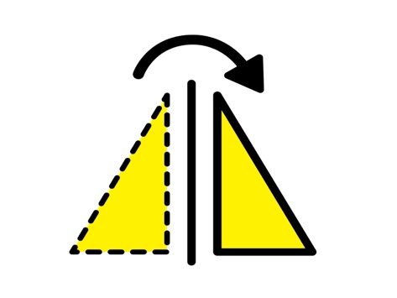 | Ready
Schedule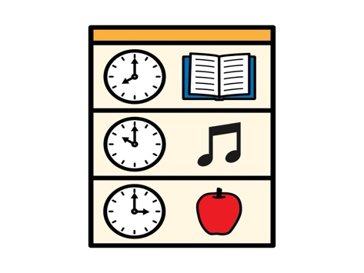 | Today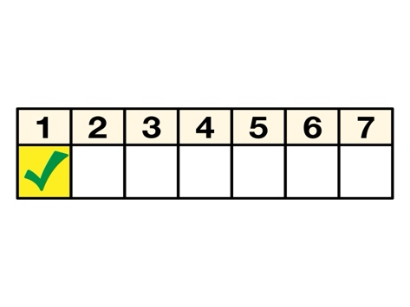 | Help